BN, Aug 10, 2019

Customer: Colorado Correctional Industries

Order Entry > File > Sales Orders > Open

This program will allow adding a Progress line at the Script 2 button of Order Entry Header by percentage of Total dollar amounts of Standard Lines.

At the Order Header, select an Order. Script 2 button is named as Progrsv Line.

The Order needs to have standard lines. Otherwise, we can not access to the custom Progrsv Line screen.

The Progrsv Line screen will have a Textbox to input a percentage for adding new Progress Billing line.

Percentage will be applied to the total dollar amounts of the order standard lines.

The new progress billing line number will be the next available line number.

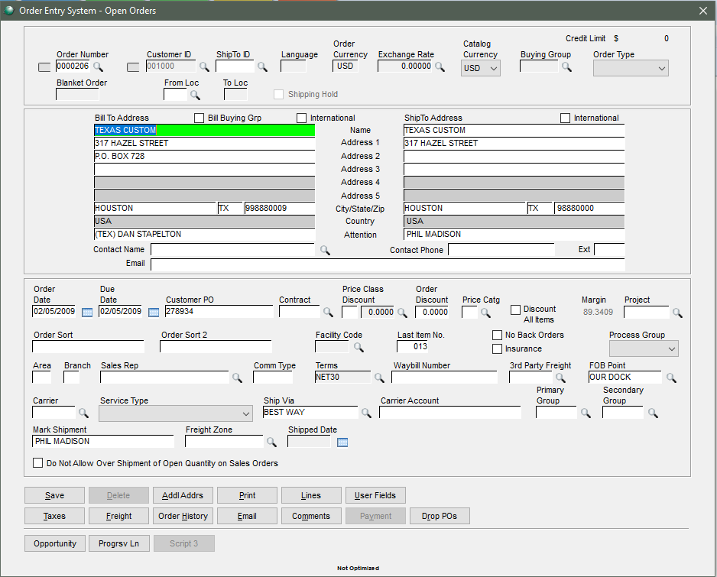

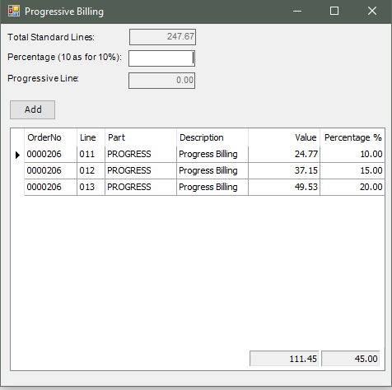

Enter 25 as for 25%, then hit Enter or Tab. The program will calculate the value of the intended Progress Line.

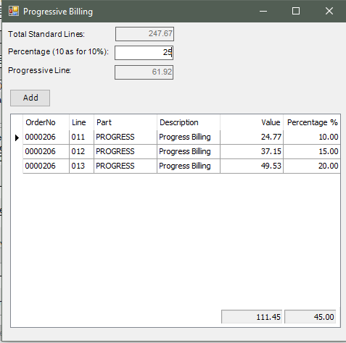

Click Add then reopen the Progrsv Line screen:

